Day27_Ride Booking Data Analysis
Scenario
You are working as a data analyst for a ride-booking company (like Ola/Uber). You received trip data stored as tuples.
Each tuple contains:
(Trip_ID, City, Distance_km, Fare_amount) Sample Data
trips = (
(101, "Bangalore", 12.5, 250),
(102, "Hyderabad", 8.0, 180),
(103, "Bangalore", 15.2, 300),
(104, "Chennai", 5.5, 120),
(105, "Bangalore", 7.8, 200)
)
Task 1: Total Trips
Find the total number of trips.
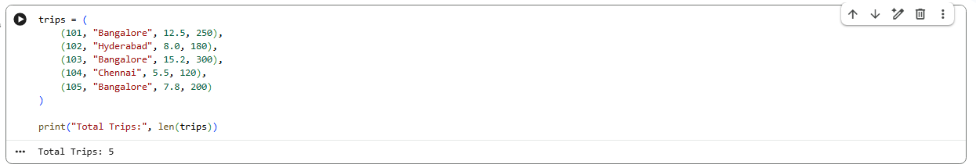
Task 2: Trips from Bangalore
Count how many trips happened in "Bangalore".
Task 3: Total Revenue
Calculate the total fare amount collected from all trips.
Task 4: High Distance Trips
Print all trips where distance > 10 km.
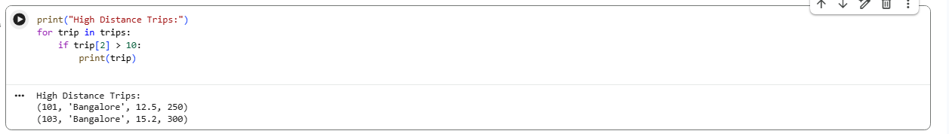

Task 5: Highest Fare Trip
Find the trip with the maximum fare.
Task 6 (Bonus - Real Analyst Thinking
Find the average fare for Bangalore trips only.
